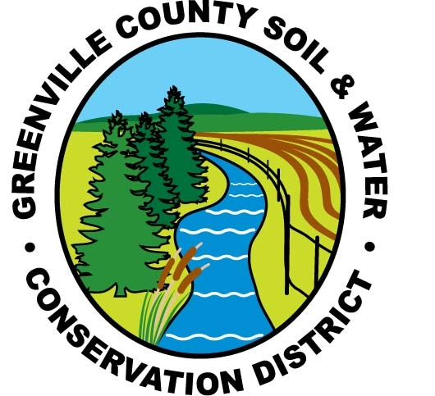

2016 Conservation Education Mini-Grants
Application Form

Criteria, Eligibility, and Timeline: Faculty and staff members of public, private, and alternative schools in Greenville County are eligible to apply for this mini-grant (up to $250) for campus conservation projects and youth environmental education initiatives. Applications received by January 15, 2016 will be considered for spring 2016 funding. Project work and the expenditure of funds must be completed by June 30, 2016.

Applicant’s name and title/position:

School:

E-mail address: Phone #:

Principal’s Name:

Principal’s Signature: ______________________________________________

- Project Overview: Describe the proposed project and how it promotes natural resource conservation and education.

- Project Budget: Add additional rows if necessary.

Item | Unit Cost ($) | Quantity | Cost ($)
Total ($)

- Funding: If your project will cost more than $250 (the maximum amount of the mini-grant), how will the rest of the project be funded?
- Project timeline: Describe your project’s timeline.

- Student Involvement:
  - How many students will be involved with this project? List by grade.

  - How will students be involved with this project?

- Collaboration: Describe if and how other faculty members, staff, parents, project mentors, or community volunteers will be involved with the project.

- Educational Outcomes: How will this project enhance student learning? Please include specific state standards and indicators addressed by this project.

- Optional Supporting Materials: You are welcome but not required to submit photographs with captions, letters of support, or other materials demonstrating why your project deserves to receive a Conservation Education Mini-Grant.

Send application and any optional supporting materials to:
Greenville County Soil and Water Conservation District
Lynn Pilewski, Education Program Coordinator
301 University Ridge
Greenville, SC 29601
E-mail: lpilewski@greenvillecounty.org
Phone: (864) 467-2755 x103

